

# PROG7313 POE: Research Document

**Compiled by:**

Ethan Moodley (ST10351721),

Nikhil Ratanjee (ST10357451),

Tariq Sallie (ST10248762)

# Table of Contents

Contents

PROG7313 POE: Research Document 1

Table of Contents 2

(1) Introduction 3

(2) App Research 3

(3) Infographic 13

(4) Best Features to include 14

(5) Conclusion 14

Reference list 15

# (1) Introduction

To develop a comprehensive personal budget tracking app, it's essential to analyse existing applications, extracting their strengths and design elements to inform our own development. We will examine 3 current budgeting apps, so that we can integrate their successful features into our design.

Incorporating gamification elements can significantly enhance user engagement in financial management apps. For instance, Mint utilizes gamification by rewarding users with badges and achievements for reaching financial milestones, such as adhering to a budget or reducing debt. Similarly, apps like Qapital and Acorns have integrated game-like features to promote savings and investment behaviors, leading to increased user participation and financial literacy. (Smartico. 2023)

By embedding such gamified features into our budget tracking app, we can make financial management more engaging and motivate users to achieve their financial goals.

# (2) App Research

**App 1: MONARCH MONEY** (By Tariq Sallie)

**Overview:**

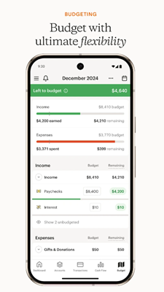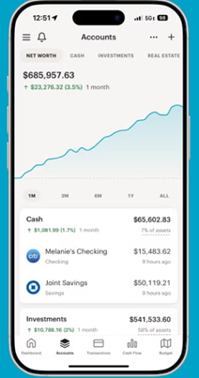Monarch Money as stated by google play (2025), is the best replacement for the Mint budgeting app. Monarch is a sophisticated budgeting app that allows its users to track, budget, Collaborate, plan and more.

(MonarchMoney, 2025). (Monarch: Budget & Track Money – Apps on Google Play, 2025)

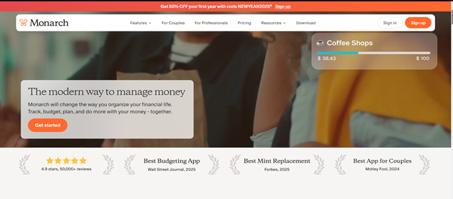The App allows users to track their transactions, investments and other features. Most notably it can provide users with a cash flow and plan a budget plan according to their monthly income. The design is clean and simple and a vast improvement from Mint. It is Highley by multiple organizations and users:

(MonarchMoney, 2025).

**Strengths and Weaknesses:**

According to (Pulliam & He, 2025) some of the pros of monarch money that make it such a recommended application are: MonarchMoney has over 13000 bank accounts available to be linked with, they have infinite saving goals for their users to optimize, they have an automatic transaction categorization feature which helps clean and manage the users transactions, a feature to create a monthly budget creation for the users, a Mobile and a web app options, the ability to add collaborators at no extra cost, and graphs and charts for data visualization for its users. These are only a few of its pros and features that make this Budget app one of the best in the market.

(Pulliam & He, 2025) also does state to the flaws of the MonarchMoney application stating that there is no free version, that it is an expensive subscription, they state that it is “geared toward traditional budgets” (Pulliam & He, 2025), and that it has a limited customer service.

While there are pros and cons for each application and system I waver that the pros outweigh the cons for MonarchMoney especially if it is being recommended by highly reputable organizations. MonarchMoney has the capabilities to help budget your expenses and manage your income and it even has the capability to tell you when you have gone over and can assist you in whatever goals you wish to achieve. This application serves as a suitable reference for designing our own Budgeting application.

**Innovative Features:**

* The ability to link with multiple banks
* The ability to add Collaborators
* The ability for Budget creation
* Infinite saving goals
* Budgeting advice
* Mobile and web app
* Data visualization

**App 2: YNAB** (By Nikhil Ratanjee)

**Overview:**

All the information and facts for the overview, including the 4 rules, on YNAB were taken form, the YouTube video “YNAB Review: The 4 Rules, Pros and Cons” by Marriage Kids and Money.

YNAB is a budgeting app that helps with tracking the in and out flows of your budget and conditions your views on spending your money, with its unique features. This app also educates you on the financial workings of the real world.

How to use YNAB? There are 4 fundamental rules that create YNAB, the rules are:

1. 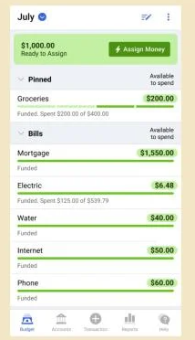“Give every dollar a Job” – for this feature you assign your money to categories, where you will be spending your money, for example Groceries.

Figure 1: YNAB/PCMag, 2024. Assigning money to categories. (Yakal, K. 2024)

1. 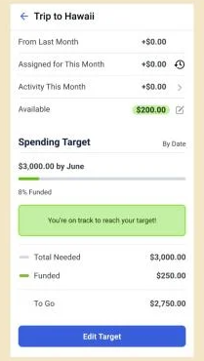 “Embrace your true Expenses” – this feature helps you set aside money for annual fees, future proofing your money.

Figure 2: YNAB/PCMag, 2024. Setting targets. (Yakal, K. 2024)

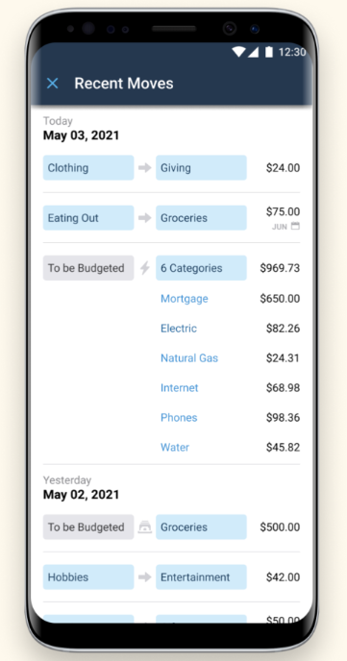

1. “Rolling with the Punches” – this feature allows you to move money between categories, creating a flexible and adaptive budget, that perfectly suits your needs.

Figure 3: YNAB, 2025. Moving Money on the mobile app. (YNAB, 2025)

1. 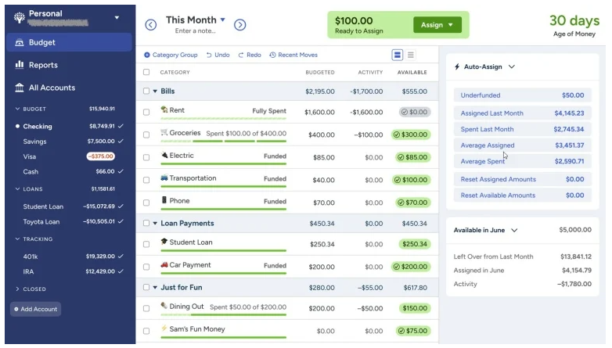 “Age your Money” – this feature lets you use last month’s income to pay of this month’s bills, helping you safeguard yourself from a financial emergency.

Figure 2: YNAB/PCMag, 2024. Showing Age of Money and budget stats. (Yakal, K. 2024)

**Strengths and Weaknesses:**

The following Strengths and Weaknesses were taken from the video "YNAB Review, 2023: The 4 Rules, Pros and Cons" and PCMag's review of YNAB, written by Kathy Yakal, 2024

Strengths:

* Zero-Based Budgeting Approach: YNAB's methodology requires users to allocate every dollar to a specific category, promoting intentional spending and effective financial management.
* Customizable Categories: Users can tailor budget categories to fit their unique financial situations, enhancing the app's flexibility.
* Multi-Device Syncing: YNAB syncs across multiple devices, allowing users to manage their budgets on desktops, smartphones, and tablets.
* Robust Educational Resources: YNAB offers a wealth of educational tools, from step-by-step Guides to a YouTube channel, to help users understand and implement effective budgeting strategies.
* Strong Security Measures: The app employs bank-grade encryption and does not store bank credentials, ensuring users' financial information remains secure.

Weaknesses:

* Subscription Cost: YNAB charges $14.99 per month or $99 annually, which is higher compared to some other budgeting apps.
* Manual Management: The app requires regular, hands-on management, which may be time-consuming for some users. Additionally there is a bit of a learning curve to use this app.
* Limited Features: YNAB lacks bill tracking, bill pay, and investment tracking features, which are available in some competing apps.

**Innovative Features:**

The following innovative features were found on YNAB’s official website (2025).

1. Bank Integration & Auto Import – Securely syncs with bank accounts for automatic transaction updates.
2. Multi-Device Syncing – Works seamlessly across desktop, mobile, and tablet, even offline.
3. Collaborative Budgeting – ‘YNAB Together’ allows up to six people to share a budget.
4. Goal Tracking – Set and monitor financial goals like savings or debt payoff.
5. Debt & Loan Management – Loan planner calculates interest savings with extra payments.

**App 3: ROCKET MONEY** (by Ethan Moodley)

**Overview:**

Rocket Money is a personal finance management app designed to help users take control of their finances. It offers a range of tools that automate the management of subscriptions, help users save money. (Hamilton, 2022)

**Strengths and Weaknesses:**

Strengths:

* User-friendly interface with intuitive navigation
* Visual dashboards and graphs provide a clear snapshot of finances
* Alerts for upcoming charges and spending to keep you informed
* Flexible pricing choose what you pay for services
* Helps identify and eliminate unnecessary subscription expenses

(Hall, 2024)

Weaknesses:

* Mixed revies online, including some BBB complaints
* Requires access to sensitive financial data
* Bill negotiation service charges a fee of 35%-60% of the savings
* To really use the application a user would have to pay for a subscription

**Innovative Features:**

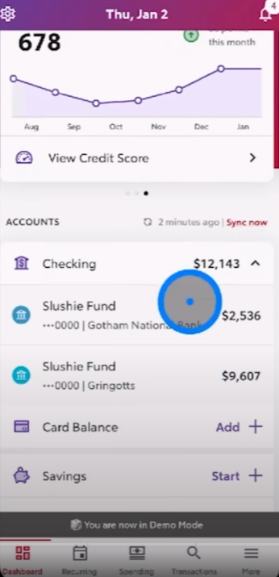This features shows all expenses that your cards are occurring which is simply a QOL (Quality of Life) feature.

(TruFinancials, 2025)

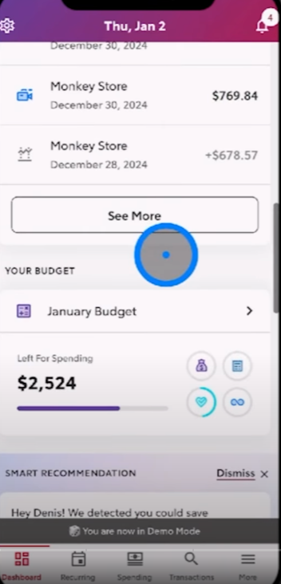This feature is a budgeting feature that allows the user to set a budget of which they are allowed to spend before getting a notification as seen by the icon on the top left that they have overspent.

(TruFinancials, 2025)

This feature allows for the user to set custom financial goals and challenges for themselves to meet to incentivize them to save money in the long term.

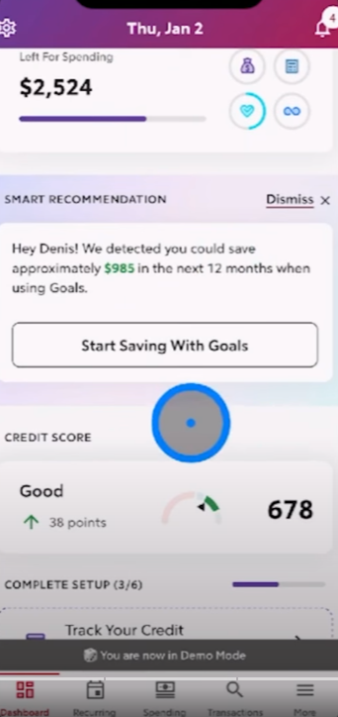There is also a feature that provides users with a full credit report and sends alerts similarly to the budgeting feature when big changes occur that could impact the users financial wellbeing.

(TruFinancials, 2025)

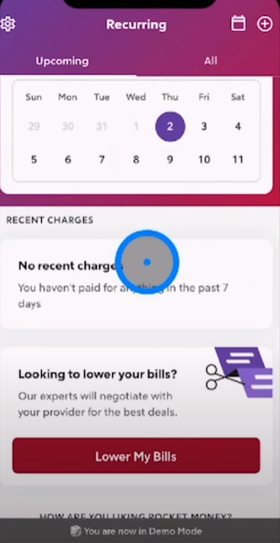This feature is one of Rocket Money’s innovative features that looks at recurring payments for potential changes to these payments that would seem out of the ordinary (potential scam) which is a security upside as well as looking for potential money wastes now that the user knows what company or where the recurring bill came from.

(TruFinancials, 2025)

# (3) Infographic

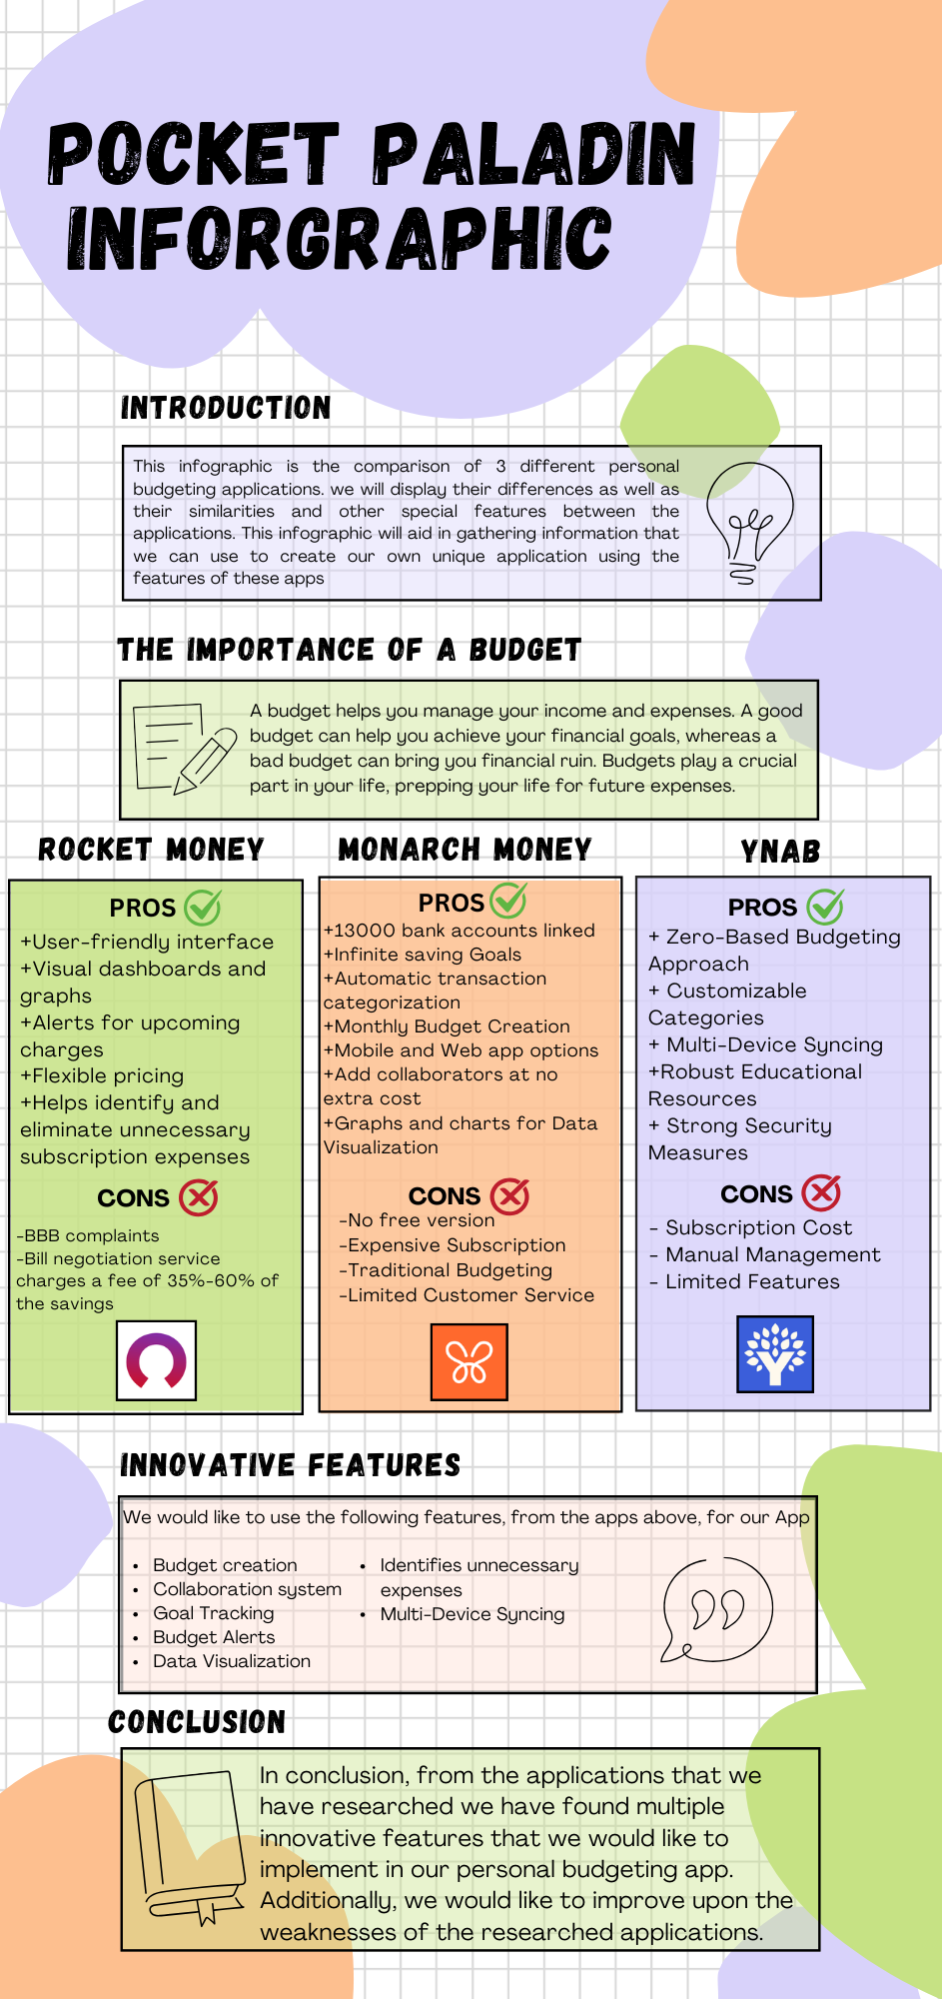

(Canva, 2025)

# (4) Best Features to include

We would like to use the following features in our App:

* **Budget creation** – Our app will be able to analyse the user’s income and expenses to create an optimal budget for them.
* **Collaboration system** – Our app should allow for multiply users to merge their budgets. So that a husband and wife can share a budget, and access it from each of their apps.
* **Goal Tracking** – The user should be able to set goals (goal to save R10 000 by September), and the app must track their goals and reward them on good progress.
* **Budget Alerts** – The app must send notifications, to alert the user on various budget updates, good and bad.
* **Data Visualization** – The app must be able to convert budget stats into graphs and diagrams.
* **Identifies unnecessary expenses** – Our budget app must outline the users’ unnecessary expenses, from month to month, and suggest changes on how they spend their money.
* **Multi-Device Syncing** – Our app must allow the user to monitor their budget from multiple devices, for example the user can access the app from their phone, tablet or laptop.

# (5) Conclusion

We were tasked with going out and researching personal budget apps in the real world. By researching the 3 apps above, we have learnt a lot, from the innovative features to the unique app features, these apps have functions that we would like to implement and features we would like to improve in our budget app.

Gamification is everything in this fast-paced world we live in, so adding gamification to our app is a must. In the budgeting application we will be building, gamification features are what will set us apart from the budget applications out right now. We will implement gamification with the use of sounds, rewards, visuals and challenges.

In conclusion, we will be using the knowledge gained from our research to build, in our eyes, the perfect gamified personal budget app.

# Reference list

Canva, 2025*. VCMoney-Infographic*. [Online]. Available at: <https://www.canva.com/design/DAGiGxxj8WY/2BtDCBSMTu3ZaZHFQW_dqw/edit> [Accessed 18th March 2025]

Hall, R. 2024. *Rocket Money Review: 6 Things to Know Before You Sign Up*. [Online] Available at: <https://clark.com/save-money/rocket-money-review/>. [Accessed 18th March 2025]

Hamilton, K. 2022. *What Is Rocket Money and Why Should You Sign Up?*. [Online] Available at:<https://www.rocketmoney.com/learn/personal-finance/what-is-rocket-money> [Accessed 18th March 2025]

Marriage Kids and Money, 2023. *YNAB Review: The 4 Rules, Pros and Cons* [Video Online] Available at: <<https://www.youtube.com/shorts/Rfqx172mmRY>> [Accessed 18th March 2025]

*Monarch Money*, 2025. Monarch Money*Track, budget, plan, and do more with your money.* [Online].Avaiable at: <<https://www.monarchmoney.com/>>.[Accessed 18th March 2024]

Pulliam, K. & He, E, 2025. *Monarch Money Review: Pros, Cons and Alternative options. Business Insider.* [Online] Available at: < [https://www.businessinsider.com/personal-finance/banking/monarch-money-review](%20https://www.businessinsider.com/personal-finance/banking/monarch-money-review). [Accessed 17th March 2025]

Smartico. 2023. *Gamification in Financial Management: Making Money Matters Fun,* 11 July 2023. [Online] Available at:<[Gamification in Financial Management: Making Money Matters Fun](https://smartico.ai/blog-post/gamification-in-financial-management#:~:text=Mint%20is%20a%20popular%20personal%20finance%20app,sticking%20to%20a%20budget%2C%20or%20reducing%20debt)>. [Accessed 18th March 2025].

TruFinancials, 2025. *How to Use Rocket Money | Beginner's Guide 2025*. [video online] Available at: < <https://www.youtube.com/watch?v=uvaliSaaa24>> [Accessed 19th March 2025]

Yakal, K. 2024. *YNAB Review,* 10 July 2024. [Online] Available at:<https://www.pcmag.com/reviews/ynab>. [Accessed 18th March 2025]

YNAB. 2025. *YNAB*. [Online] Available at:<https://www.ynab.com/>. [Accessed 18th March 2025]